KStars for Mac Quick Start Guide

1. After mounting the DMG, drag the KStars.app application bundle to your /Applications folder or anywhere you would like to put it on your Mac. If you would like to plate-solve images using the "local" astrometry.net solver inside the app bundle, please **do not put it in a folder that has a space anywhere in the file path**. If you choose to use the new internal StellarSolver, this should not matter.
2. Double click on the KStars.app. On the first run, several things will happen that should not happen later if you run it again.
   1. A dialog box might pop up saying it is from an unidentified developer. This is because KStars is open source software. You should be able to right-click (or ctrl-click depending on your Mac) and select “Open” from the top of the contextual menu to get KStars to open. If you still cannot run it, then you may need to change your security setting in System Preferences.
   2. A dialog box might pop up saying that KStars was downloaded from the Internet. Click ok to run it.
   3. If you have not had KStars installed before, then KStars will need to copy the data directory into your Library folder. The wizard will help you do this.
3. KStars should now be working well. The rest of these steps are optional.

GSC

If you want to run gsc to get “stars" in the CCD simulator, you can use the downloader in the startup wizard or your can download and unzip this file <http://www.indilib.org/jdownloads/Mac/gsc.zip> into the KStars Data directory ~/Library/Application Support/kstars

Python and Astrometry.net issues and the new StellarSolver

The local Astrometry.net solver traditionally relies on Python for plate solving images. We have had difficulty with this in the past, since while MacOS does include Python, it hasn't been Python3 which astrometry.net prefers, nor has it been easy for users to install the packages needed to use it with astrometry.net. So often, users have other Python installations on their computers. In fact, at times users have had 4 different Python installations simultaneously on their Macs. This had led to lots of confusion in getting Python set up to handle astrometry.net for KStars.

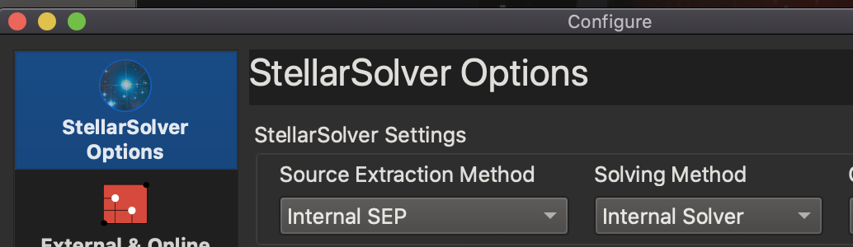 So recently, I created a new internal plate solving library called StellarSolver based on astrometry.net. It is my hope that this solves all those problems by having an internal build of astrometry.net that plate solves internally to KStars with no need for any temp files or external configurations like Python.

StellarSolver is also capable of plate solving using other methods. If you have any difficulty with the internal solver, you can try one of the following:

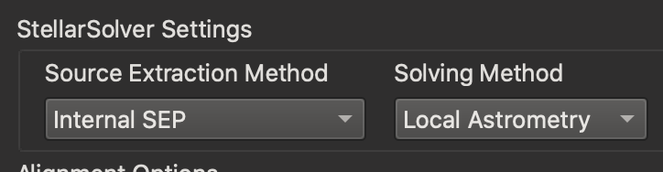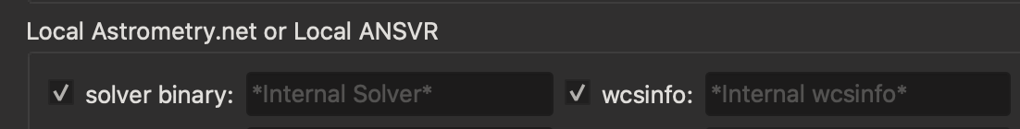

1. Internal SEP or external SExtractor with the "local" astrometry.net solver. Embedded inside the KStars app, you can currently still use the same astrometry.net I have been distributing with KStars for the last few years.

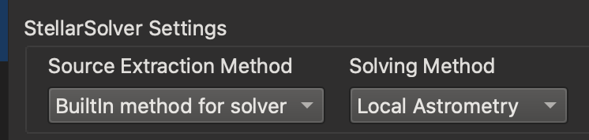

1. "Built In" Source extraction with the local astrometry solver. I have recently updated StellarSolver so that it can work with the local astrometry.net solver and never use Python.

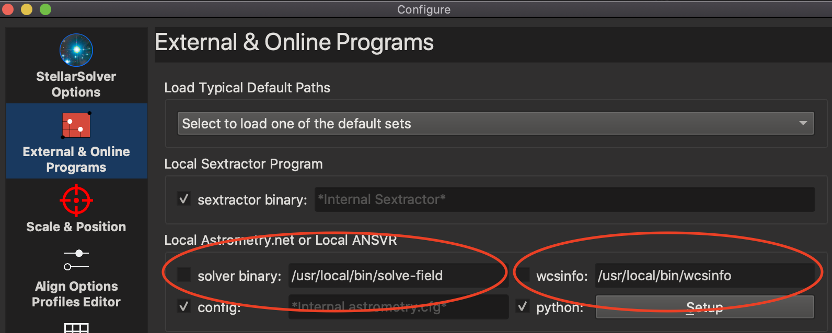

1. Using the astrometry.net package from Homebrew (using any of the source extraction methods). If you are having issues with both the Internal StellarSolver build and the local astrometry solver provided with the KStars app, if you have homebrew you can install astrometry.net using homebrew using this command: brew install astrometry-net

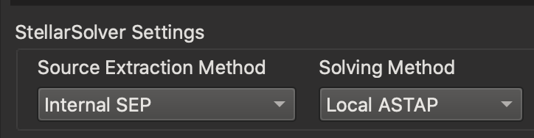

4. StellarSolver can also make use of ASTAP (with any of the source extraction methods). You can download ASTAP from this website, along with the star databases:

<https://www.hnsky.org/astap.htm>

Astrometry.net configuration

If you would like to run Astrometry offline on your Mac (not ASTAP), you will need to copy some index files into ~/Library/Application Support/Astrometry/. KStars has installers for these files in the Astrometry options in the Align tab in Ekos

1. If you just want to try out Astrometry on KStars using the fake gsc based images using the CCD simulator, then be sure to follow all of the instructions above, and download the 4205 series and 4206 series index files. Then it is jut a matter of adjusting your settings in the align tab and astrometry options.
2. If you instead want to use a real telescope and imager, the exact index files you will need depends on your field size. In the Ekos Align Module, the astrometry options will make some recommendations based on your field size. Also, the Astrometry Readme file explains this well [astrometry.net/doc/readme.html](http://astrometry.net/doc/readme.html). However, I have found that the easiest way to determine what you will need is to just take a few images in different areas of the sky using your system and upload them to [nova.astrometry.net/upload](http://nova.astrometry.net/upload). Pay attention to which index files solve your images. Then download those series of index files using the installer in the Astrometry Options in the Align tab in Ekos. If the download times out for whatever reason, you can also download the index files from the astrometry.net website and copy them into ~/Library/Application Support/Astrometry/.

Updating KStars

Most of the time, to update to the latest version of KStars, all that you need to do is download the new DMG from the KDE website, mount the disk image, and drag the app to wherever you installed the old KStars.app. You can delete the old one first, or drag the new one over the old one and replace it. It will overwrite the previous copy. All of your preferences, settings, and data files are stored in other locations, so this overwrite should not cause any problems with your saved information. Once in awhile though, there could be a compatibility issue between one of your old files and the newest version of KStars, in which case you will want to read the next section.

Resetting files in KStars for Mac (not usually necessary)

Sometimes, unfortunately, if some files or settings get corrupted, or if there is an incompatibility between a file you have and a new version of KStars, it might be necessary to remove or replace key files KStars has installed. Most of the time this does not happen, but if it does, it helps to know where those files are and how to do that. Deleting the files is a last resort since you will lose settings, but it could fix almost any installation problem since those files will be recreated with their default settings the next time you start KStars.*

Most of the time the files that could cause issues would be either files inside the data directory* and/or the KStars preferences file, so those would be places to start if you are having issues. A good option could be to backup and/or rename the files/folders before you delete them, that way you could potentially get your settings back. Another option might be to copy known working copies of the files (like backup versions). Here is a list of files KStars installs:

The KStars App bundle: KStars.app

Could be anywhere you put it, but it is likely in /Applications/KStars.app

The KStars Data Directory

~/Library/Application Support/kstars

The Astrometry Index files

~/Library/Application Support/Astrometry

The kstars preferences file

~/Library/Preferences/kstarsrc

The kstars notifications preferences file

~/Library/Preferences/kstars.notifyrc

The kstars messagebox preferences file

~/Library/Preferences/kstars.kmessagebox

The Translations Directory

~/Library/Application Support/locale

The Notifications Directory

~/Library/Application Support/knotifications5

*Please note for the Data Directory, the way that it works is that if it doesn’t find the data directory at the location it belongs, it copies a complete replacement data directory into place from inside the app bundle. There are some files inside the data directory that can just get recreated if you delete them, but not all of them. So, if your issue is caused by a file in the data directory, deleting the whole directory is the easiest option. But you can also try manually copying in a replacement file from a known working KStars data directory or from inside the app bundle if you don’t want to lose other settings.

Uninstalling KStars

You can uninstall KStars by just deleting the KStars.app bundle. If you want to, you can also optionally remove the other files listed above. Just note that if you just delete KStars.app, the app will be gone but your settings will be preserved if you ever want to use KStars again, but if you delete the other files, your settings will be lost for good.